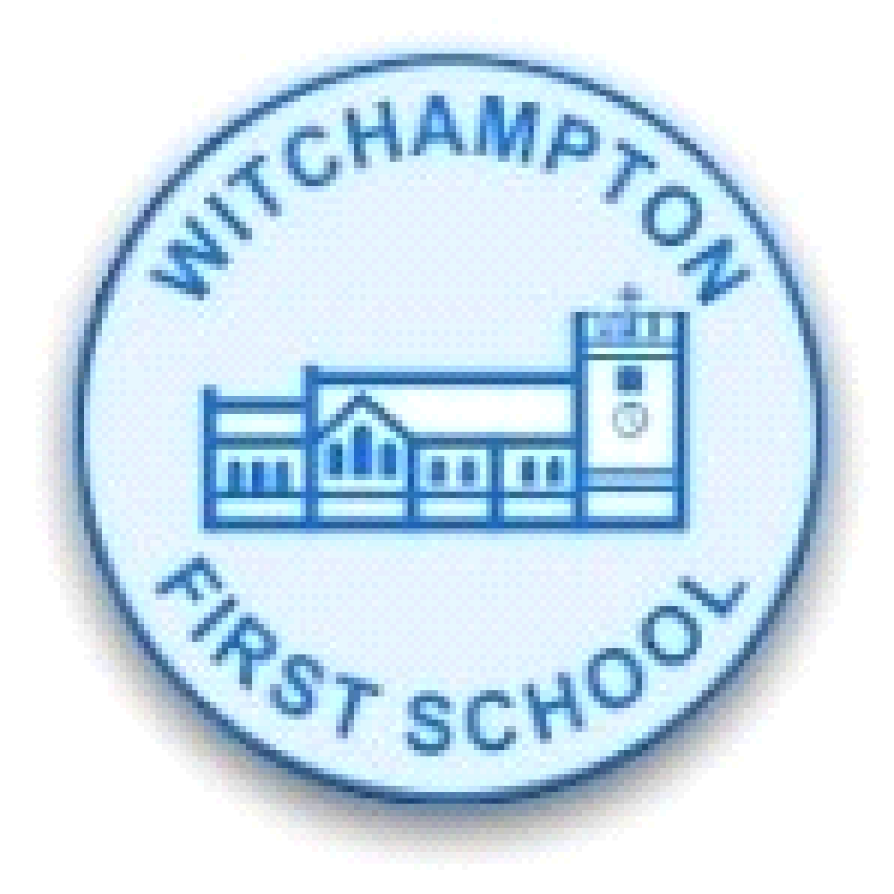
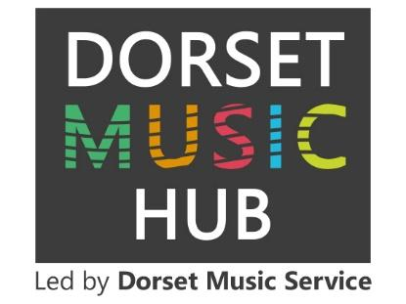
Witchampton C of E First School
School Music Development Plan

Step 1 – Look at your School Music Policy and vision for music in your school.

Step 2 - Audit your school’s current provision according to these levels and your music policy and vision:

- Focusing – The school is beginning to focus on this area. Action is taken to achieve this by the school, but it is either minimal, not successful, or in its early stages.

- Developing – The school is actively trying to develop this area. Several different actions are being taken over a sustained period, which are beginning to show progress, even if in their early stages. The actions taken are more developed than in focusing.

- Establishing – Over time, the school has established provision that shows successful implementation of this area within the school’s music education offer.

- Enhancing – over time, the school has created nationally significant provision that is able to have impact at scale. The school’s music education provision is at the heart of the school life. New and innovative ways to meet this area are in place or are being developed in school.

Curriculum music | Focusing | Developing | Establishing | Enhancing
Curriculum music | Music is delivered ‘ad’ hoc’ and not in every year group. Some groups of students are unable to access the music curriculum.  Progress over time is not measured or celebrated.  There are limited resources for teaching. | Music is a timetabled subject, with schemes of work and assessment in place. All students can access this curriculum from EYFS to Year 6.  Students engage with schemes of work and build areas of musical interest and growing skill.  Pupils with SEND can participate and engage in music-making.  There is adequate space and resources for teaching, including class sets of tuned and untuned instruments. | The music curriculum is at least as ambitious as the National Curriculum and draws on insights from the model music curriculum. Curriculum sequencing is clear.  Good progression is demonstrated by secure and incremental learning of the technical, constructive, and expressive aspects of music, developing musical understanding.  Pupils with SEND can participate and progress well (supported by technology, tools and adapted instruments). Space and resources allow breadth of curriculum for all students, including music technology. | Curriculum goes beyond the level of the National Curriculum, seeking to address social disadvantage by addressing gaps in knowledge, skills, and experiences.

Co-Curricular | Focusing | Developing | Establishing | Enhancing
Co-Curricular | Singing takes place infrequently and repertoire is not varied.  There are opportunities to perform for a small number of pupils. There may be barriers to participation.  Facilitation of one to one and small group tuition is limited and inconsistent.  Musical skills and interests cannot be extended as the enrichment offer is limited and local opportunities are not signposted. | Singing and vocal work is frequent, varied and all students are engaged. All pupils, including the most disadvantaged and pupils with SEND, have an opportunity to perform regularly. In school musical events take place at least termly.  The school facilitates one to one and group tuition. Pupils and families facing the largest barriers are given support to engage in music learning as part of, and beyond, the curriculum.  Musical skills and interests are extended through extra-curricular activities, such as the music clubs, and all pupils are given the opportunity to participate. Local opportunities are signposted. | Singing and vocal work is embedded into the life of the school and into every child’s experience, drawing on a wide range of high-quality, age-appropriate repertoire and developing musicianship. All staff in the school are able to support singing.  Music performance is a prominent component of school life from an early age; music is performed in assemblies and events such as open evenings alongside in-school events. Students also perform to the wider community in local/regional events. In school musical events take place at least twice a term.  The overall provision is diverse, valuing all musical styles, genres and traditions equally; this is reflected in the clubs and enrichment programme and drawing on the skills, talents and interests of staff and local stakeholders through specialist tuition. A large proportion of students are involved. | A full, long-term singing strategy is in place that ensures progression for all students.  The school tracks and monitors engagement in enrichment, ensuing that there is a large proportion of students able to engage in music in and out of school. Provision is targeted, demonstrating wider impact.  Students can take leadership roles in musical opportunities.  The school is actively involved in national, largescale events.

Leadership and Management | Focusing | Developing | Establishing | Enhancing
Leadership and Management | A named subject lead is in post.  Training for staff delivering music has limited impact. | A named, trained subject lead is in post.  The subject lead is supported by a senior leader advocate in school, who understands the National Curriculum and is aware of the National Plan for Music Education.  All staff delivering music receive annual training, addressing their CPD needs and has impact. | Music is explicitly referred to in the school improvement plan and the department development plan drives continuous improvement.  A named member of the governor board takes a special interest in subject provision, supporting strategic development and holding leaders to account.  All staff receive annual training to maintain their confidence and build expertise. | There is a five-year strategic vision for music that is in line with the National Plan for Music Education.  Staff deliver training beyond their own school setting, sharing expertise more widely.

Community and partnerships | Focusing | Developing | Establishing | Enhancing
Community and partnerships | Engagement with the Music Hub is inconsistent. Small scale performance takes place in the community, building on existing school links.  Some parents and carers support music-making in the school by attending events. | The school takes up opportunities from the Music Hub and signposts opportunities for students.  Community links with music are established, and regular events take place throughout the school year.  Parents and carers actively support music making, through support at events and through home learning. | The school makes the most of a wide range of opportunities from the Music Hub, working as an active partner.  Meaningful partnerships are established with the community where a large proportion of students engage with this and there are clear civic and moral benefits.  The views of pupils and parents have been considered when developing music provision. | The school is a leading school in the local community and with their Music Hub.  There is a co-ordinated programme of community events, planned in partnership.  Parents/carers and the wider community are actively involved in school music making.

Opportunities beyond the statutory expectations:
- Music lessons on offer in ukelele, guitar, clarinet, piano and singing.
- All children in year three and four have the opportunity to learn two instruments for two terms over a two year period. Recently instruments have included ukulele, recorder, samba and music tech.
- Regular opportunities to perform either as a soloist, in a small group or in the choir eg: singing to the WI, school nativity singing and as instrumentalists, regular church services, the summer fete, the annual village concert (where many children perform), bi-annual trip to see the BSO in KS2, the annual talent show, special achievements in celebration worship performances, some visits by soloists and small groups (this could be increased).

Step 3 – Based on the judgements made above, set your school 3 areas to develop in the next academic year.
What do you want to change or develop? | Why do you want to change it? (Where are you now) | Where do you want to be and by when? | How will you get there? What are the steps you will take? | What will you need to do this? (Resources, guidance, time, etc)
1.  Confidence of staff to adapt existing planning to meet the needs of their class to ensure one hour of high quality music is taught each week. | The school has a well thought out sequenced curriculum to ensure progression. Staff do not currently feel they have the subject knowledge and skills to adapt the planning to meet the needs in their class and to deliver the lesson effectively. | Over a two year cycle staff will be confident to deliver the music curriculum, including singing/rapping, listening, composing, music tech, performing, notation and theory.  All class music lessons will be of a high quality by July 2025.  All staff will enjoy teaching music to their classes. | Engage with the Dorset Music Service to receive termly staff training on a specific area of the music curriculum. Sessions will be delivered in priority order starting with the use of melodic and rhythmic instruments.  A staff meeting led by a Dorset Music Area Leader.  Additional training and attendance at networks for the music lead in school. | Staff meeting time.  Dedicated time for the music lead.  Dedicated time for teachers to work with the music lead to discuss and adapt planning.  The purchase of additional tuned and untuned percussion.
2. Strong music leadership. | The current music lead is leaving. This post will need to be replaced across two schools. A handover to the new music lead will be necessary and this will require training and support from experts. We offer a wide range of opportunities beyond the statutory expectations (see list above) and these will need to be sustained and developed. | An established music lead will be confident to support staff and monitor the quality of music provision in school by the end of the summer term 2025.  The music lead will ensure the current strong community partnerships are sustained and further partnerships are forged. This will include further opportunities to develop partnerships with Pamphill First School. | ti  Thorough handover by existing music lead.  Opportunity to meet with senior leader.  Training and support from experts.  Attendance at training and networks. | Time for music lead to work with experts and attend training and networks.  Time for a hand over.
3. To develop the use of  both rhythmic and melodic instruments across the school | Our audit of rhythmic and melodic instruments has shown that the current stock of instruments is not of high quality and does not meet the need in school to ensure progression and high quality delivery of music lessons.  Some existing instruments such as ocarinas are not being used to support children’s learning and are a wasted resource.  Staff say that they do not feel confident in using these instruments in their lessons. | An improved stock of high quality rhythmic and melodic instruments by end of summer term 2024.  Staff confident to teach using new and existing rhythmic and melodic instruments.  Staff able to adapt planning to include a wider range of high quality instruments taught in a progressive way. | Work with Dorset Music Service to gain support and advice on which instruments to purchase.  Staff training from Dorset music service to develop skills to use the instruments as teaching tools.  Music Lead to monitor the use of instruments in lessons. Music Lead to identify further training and resource needs.  Music Lead to measure the impact of training on quality of music lessons. | Advice from Dorset Music Service to purchase appropriate instruments.  Funding to purchase instruments.  Training from Dorset Music Service for staff (linked to area 1).

Step 4: Share your areas of development with Dorset Music Hub so they can see how best to support you to achieve your goals.


