Witchampton C of E First School
Parents’ Guide to Google Classroom

How to log in
Go to www.classroom.google.com
To sign in, students must enter their school login credentials. This is their school e-mail address and password
(The format is Intake Year of Reception start Lastname Firstname @witchamptonfirstschool.org )
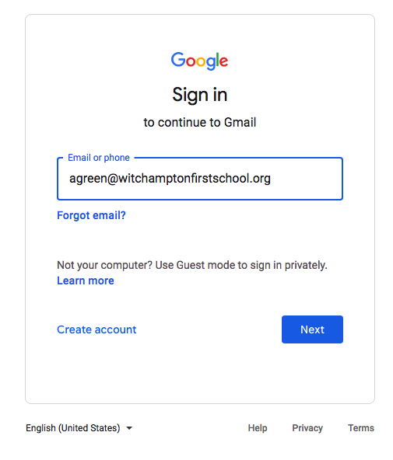
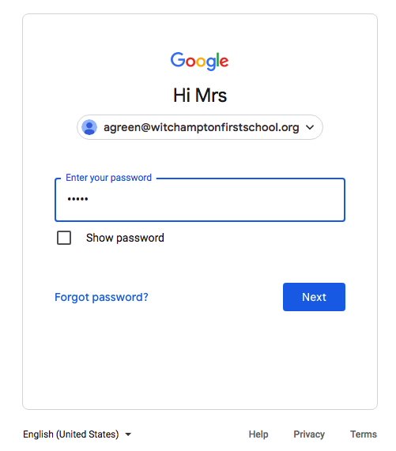

Click on I’m a student on this page (it may or may not come up):
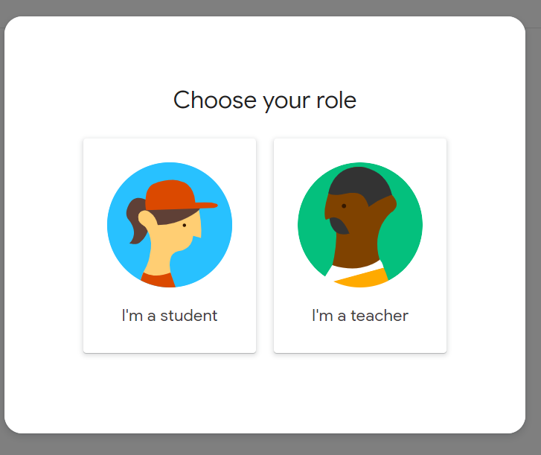

Then you will see this page - but for the class your child is in:
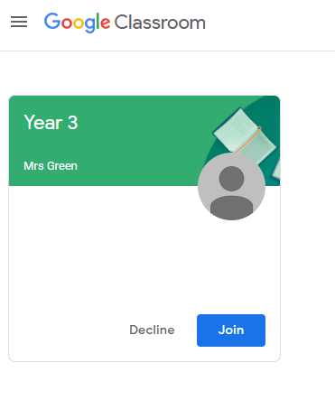or 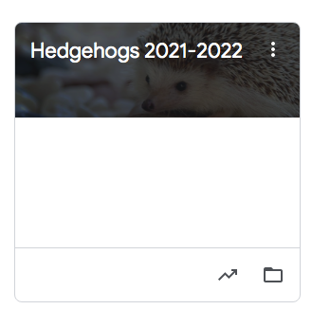
Click ‘Join’ on that page. Once this has been done, you won’t be asked again the next time you login. (This may have already been done for you, which is fine!).

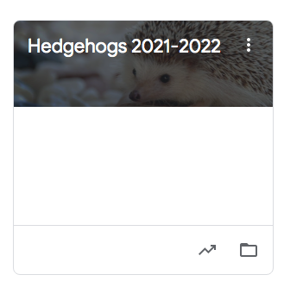
If that has already been done, then click on your class / year group:
Eg.

You will then see any messages from your child’s class teacher with some learning activities or a message.
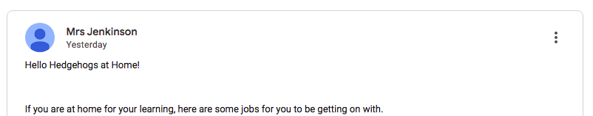

You may have some assignments (tasks) in the STREAM or in the CLASSWORK tabs which have been set for your child to do, such as Home Learning. This is used more for Years 1-4.

It will look something like this from your child’s class teacher:
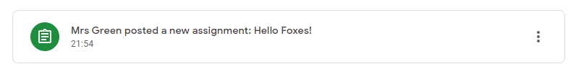

Click on the assignment – over the letters or on the coloured symbol. This will open the assignment (task) and give you more details.

When your child has completed any assignments, click ‘Mark as Done.’ This sends your teacher a message to show you have completed your task. Well done!

You can add a Private Comment for your teacher to see, if you would like to.
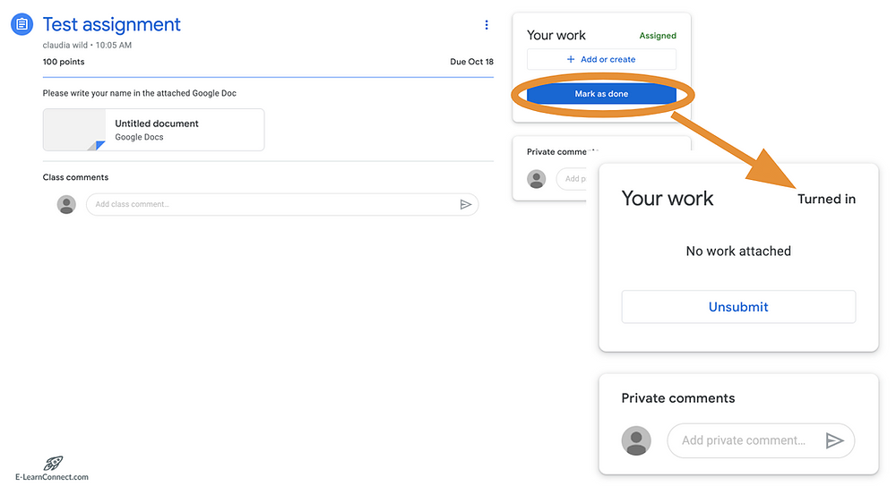

It shows how you can add photos to send to your teacher of any work you would like to submit. (It explains in more depth at the end of this document)

More info: Welcome to your classroom:
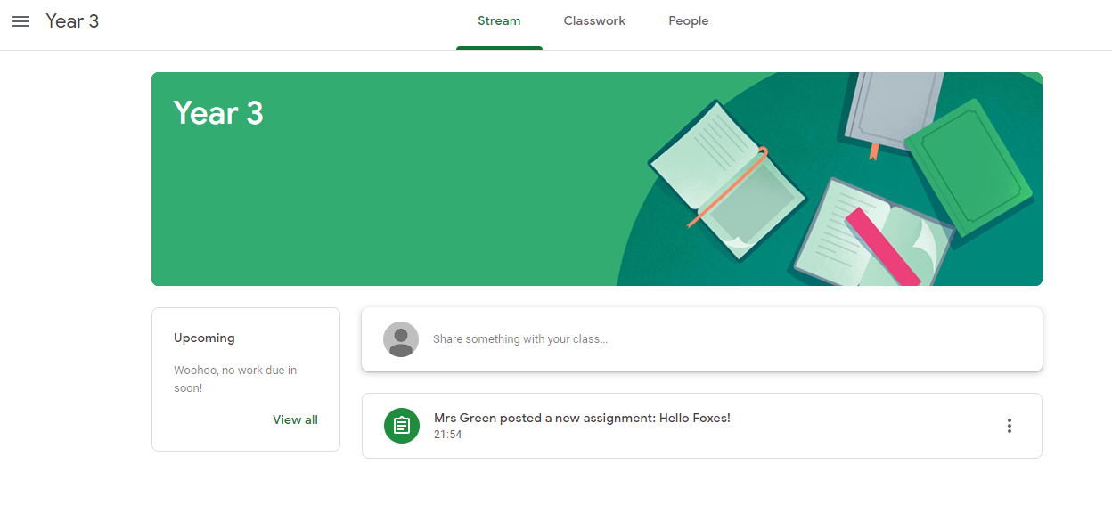
The "Stream" Page
The stream works similarly to a social network page. The most recent post that a teacher has added to the Google Classroom will be at the top and the oldest will be at the bottom. Each post will be associated with the subject that the student is learning with that teacher. When a teacher posts an assignment on their Google Classroom, it will contain the name of the task, a description of what the student has to do and possibly associated resources where possible. It will also have a due date for when the work needs to be completed by. Students will be guided by their teacher on whether they complete their work online using Google Classroom or offline in another way.

Completing/Submitting Work Online
If students have to complete their work online, they will need to click on the name of the assignment followed by "Add +". A drop-down menu will appear where they can choose to create a Google document or upload a file from their computer or their online storage Google Drive. Or they can open a template created by the teacher. This will appear above the add button.
Having added their chosen document, it will appear in the white box just above the "Add +" button.
If a student has chosen to create a new document from the "Create" section, then they simply need to click on the file and then they can start their work. The file will open in a separate tab and will save automatically until closed. The student can go back to this document to work on it as many times as they wish until they need to submit it.
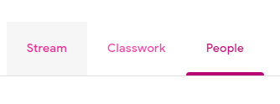
After the work has been completed or added to the assignment, then the student will need to press the "Hand In" button. See image below.

Classwork tab- Shows all previously created and current assignments
People tab- Shows teachers and other classmates

Mobile Apps
Students have the opportunity to download Google Apps for their handheld device. They are free but they must remember to use their school login details as mentioned at the top of the page as opposed to any other Google account that they use at home. Inside each app, they will give the user the choice on which to use. The recommended apps are the following:
- Google Classroom
- Google Drive
- Google Docs (free alternative to MS Word)
- Google Slides (free alternative to MS PowerPoint)
- Google Sheets (free alternative to MS Excel)

